UCAB – Online Cab Booking Application
Project Report
1. Introduction
1.1 Project Overview
UCAB is a web-based cab booking application built to give users a fast and reliable way to book a cab online. It has three types of users – User, Driver, and Admin – each with their own dashboard. The project is built using the MERN stack (MongoDB, Express.js, React.js, Node.js).
1.2 Purpose
The purpose of UCAB is to make cab booking simple and organized. Users can search for available cabs, see the estimated fare, and book a ride without calling anyone. Drivers get an organized way to receive and manage ride requests, and the admin can manage users, drivers, cars, and bookings from one dashboard.
2. Ideation Phase
2.1 Problem Statement
People in the city often struggle to get a cab quickly, especially during heavy traffic or at odd hours. They don't know which cabs are nearby, how long the wait will be, or what the fare will be before booking. Cab drivers don't have an organized way to receive ride requests, and there is no single system for an admin to manage users, drivers, cars, and bookings together.
2.2 Empathy Map Canvas
For a typical user (a working professional who needs a cab daily): they SAY they want a cab that arrives on time and at a fair price; they THINK about whether they will reach on time and how much it will cost; they DO call local drivers or wait on the road for a taxi; and they FEEL stressed and unsure until the ride is actually confirmed. This shows the need for a simple app where booking and fare are both clear upfront.
2.3 Brainstorming
The team brainstormed several ideas before finalizing the solution, including:
- A single app for users, drivers, and admin instead of separate systems.
- Showing an estimated fare before the booking is confirmed.
- A separate driver dashboard to accept and manage rides.
- A centralized admin panel to manage users, drivers, cars, and bookings.
- Keeping the login and booking flow as simple as possible for the user.
3. Requirement Analysis
3.1 Solution Requirement
The main requirements identified for UCAB were: user registration and login, cab search and booking, fare estimation, booking history, a driver dashboard for ride management, and an admin dashboard for managing users, drivers, cars, and bookings. Software requirements include Node.js, npm, React.js, Express.js, MongoDB, and a code editor such as VS Code. Hardware requirements are a standard development machine with at least 8 GB RAM.
3.2 Data Flow Diagram
The data flow for UCAB starts when a user logs in and searches for cabs. The request goes from the React frontend to the Express backend, which checks the MongoDB database for available cabs and returns the fare and cab details. Once the user confirms a booking, the booking data flows to the database and is made visible to the assigned driver and to the admin dashboard.
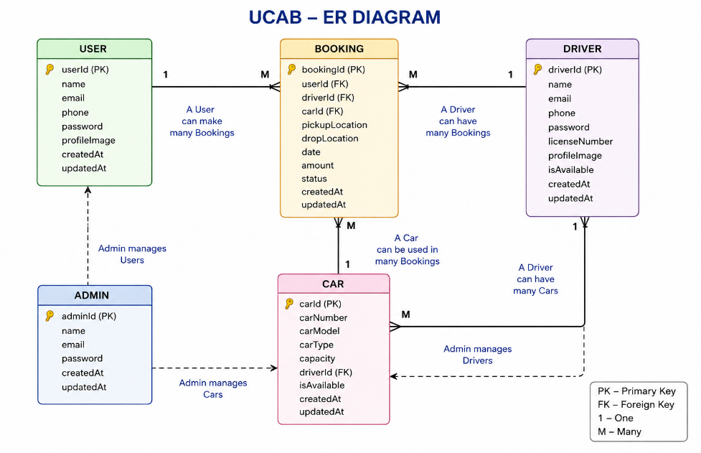
Figure 1: UCAB Entity-Relationship Diagram
3.3 Technology Stack
UCAB is built using the MERN stack:
- Frontend: React.js (Vite), HTML, CSS, JavaScript
- Backend: Node.js, Express.js
- Database: MongoDB with Mongoose
- Authentication: JWT and bcryptjs for secure login
- Deployment: Vercel (frontend hosting)
4. Project Design
4.1 Problem – Solution Fit
The problem is that people cannot easily find and book a cab, and drivers and admins don't have an organized system either. UCAB solves this with one online platform: users can search, check fare, and book a cab in a few clicks; drivers manage rides from their own dashboard; and the admin manages the whole system from a separate dashboard.
4.2 Proposed Solution
UCAB is an online cab booking web application built on the MERN stack. It brings the user, driver, and admin onto one platform, each with a role-based dashboard, along with an upfront fare estimate. This saves time for users, gives drivers a proper platform to get rides, and can be scaled to more users, drivers, and cities as the MongoDB-based backend is not tied to a fixed location or user base.
4.3 Solution Architecture
The architecture has a User Interface layer for User, Driver, and Admin dashboards, a Web Server layer (React frontend and Express/Node backend), an Application Services layer (Authentication, Booking, Driver, Car Management, and Admin services), and a MongoDB database that stores all application data.
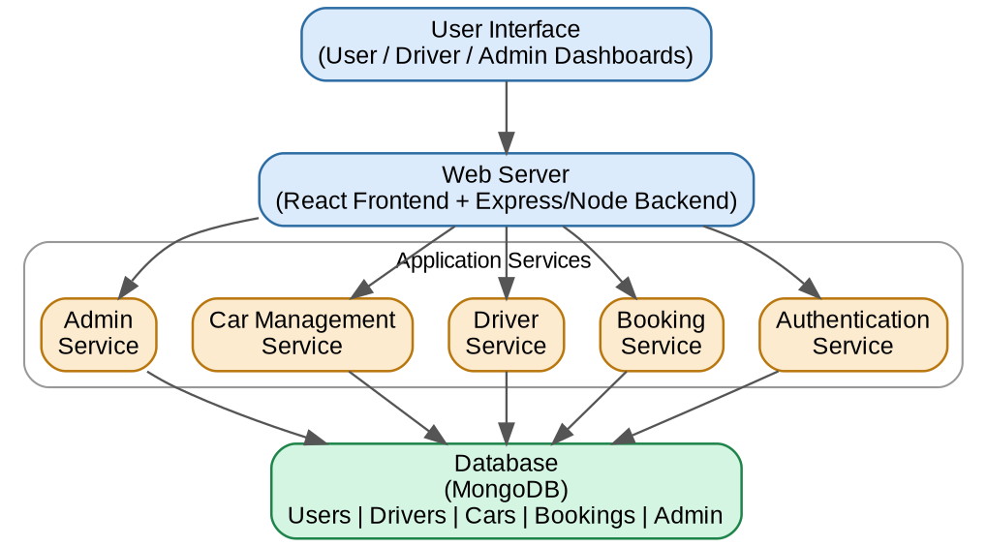
Figure 2: UCAB Solution Architecture
5. Project Planning & Scheduling
5.1 Project Planning
The project was carried out in phases: requirement gathering and ideation, UI/UX design, frontend development using React, backend development using Node.js and Express, database design in MongoDB, integration of frontend and backend, testing, and finally deployment. Each phase was completed before moving to the next to keep the development organized.
6. Functional and Performance Testing
6.1 Performance Testing
The APIs were tested using Postman to check response time and correctness for login, booking, and admin operations. The application was also tested with multiple simultaneous requests to check that booking and data updates worked without errors.
6.2 User Acceptance Testing
The team tested the complete user, driver, and admin flows end-to-end – registering, logging in, searching and booking a cab, accepting a ride as a driver, and managing users/drivers/cars/bookings as admin. All the core flows worked as expected before the application was deployed.
7. Results
7.1 Output Screenshots
The working application was demonstrated with a full walkthrough of the code and a live demo of the deployed website. Sample screens from the application are shown below.

Landing Page
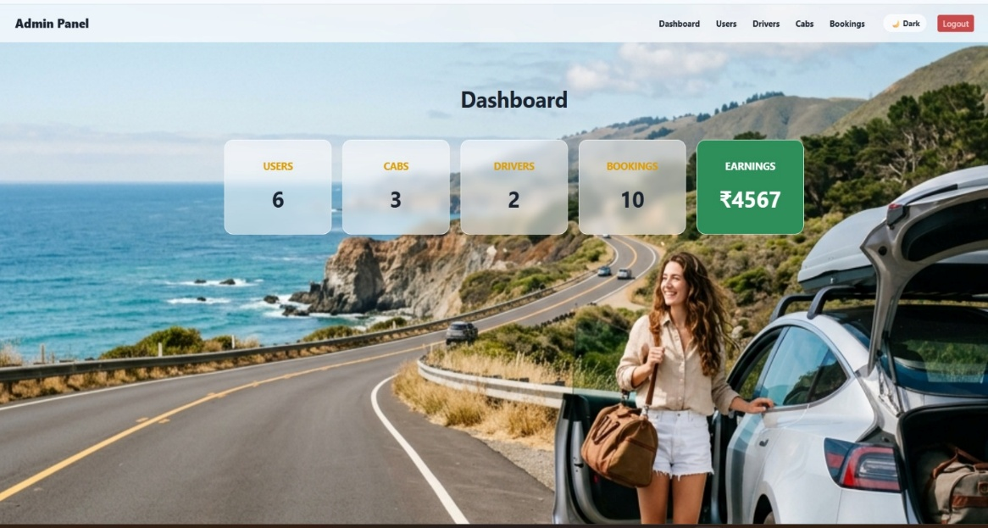
Admin Dashboard
8. Advantages & Disadvantages
Advantages
- Saves time by showing fare and cab availability upfront.
- Organized ride requests for drivers instead of random calls.
- One dashboard for the admin to manage the whole system.
Disadvantages
- Requires internet access to use the application.
- Currently does not have live GPS tracking of the cab.
- Payment is not yet integrated into the app.
9. Conclusion
UCAB is a MERN stack based cab booking application that gives users, drivers, and admins a single, organized platform for booking and managing rides. It makes the cab booking process faster, more transparent, and easier to manage compared to the traditional way of calling or waiting for a cab.
10. Future Scope
- Live GPS tracking of the cab during the ride.
- Online payment gateway integration.
- Rating and review system for drivers and users.
- Expanding the application to more cities.
11. Appendix
Source Code
https://github.com/vasanthimunduri/U-Cab
GitHub & Project Demo Link
GitHub: https://github.com/vasanthimunduri/U-Cab
Live Demo: https://cab-nine-theta.vercel.app/

